Red Ribbon Week 2025
Hawks Rise Spirit Days!
You are invited to participate in a spirit week to celebrate making healthy and safe choices!
October 27-31
Monday 10/27 | Tuesday 10/28 | Wednesday  10/29 | Thursday 10/30 | Friday  10/31
Wear RED to celebrate being drug free.  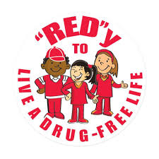 | Be ALL that you can be! Wear CAMO gear!  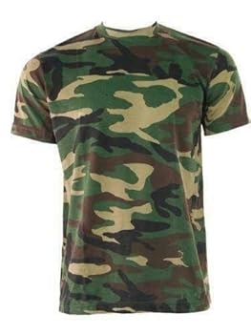 | Team up against drugs! Wear your favorite  TEAM shirt!  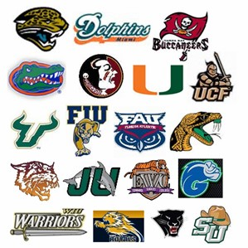 | Hats off to being drug free! Wear your favorite HAT!   | Spirit Day! Grade level choice. Drugs are a TRICK, not a treat!  

